
“Warthog Pump Owner’s Manual” 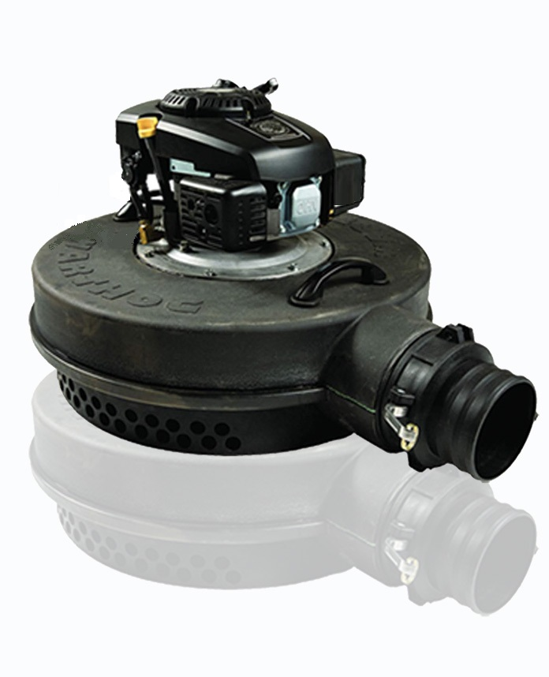
Rugged, Reliable and Ready
Like mother nature’s creation, tough, reliable and comfortable in water and sludge.

Manufactured by: Warthog Products International Inc.
Regina, Saskatchewan, Canada
Your WARTHOG PUMP must be shipped dry WITHOUT engine or gear case oil.

CAUTION
Do not start engine until oil is added to the engine AND gear case.
Read this manual and the engine owner’s manual carefully before operating your WARTHOG PUMP.

Before Starting the Warthog Pump
- Important
Engine - Refer to the engine owner’s manual for minimum engine oil requirements and fuel requirements.
Also refer to engine owner’s manual for oil change requirements, engine service requirements, engine starting instructions and use of the manual choke.
Gear Case - The gear case in your WARTHOG PUMP requires 1 litre (35 ounces) of GEAR OIL. Remove the gear case oil plug, (see picture). Then fill the gear case with the recommended amount of oil as shown and replace and tighten the oil plug. Fill only to level that is 35-40mm from the top of the oil fill plug opening.
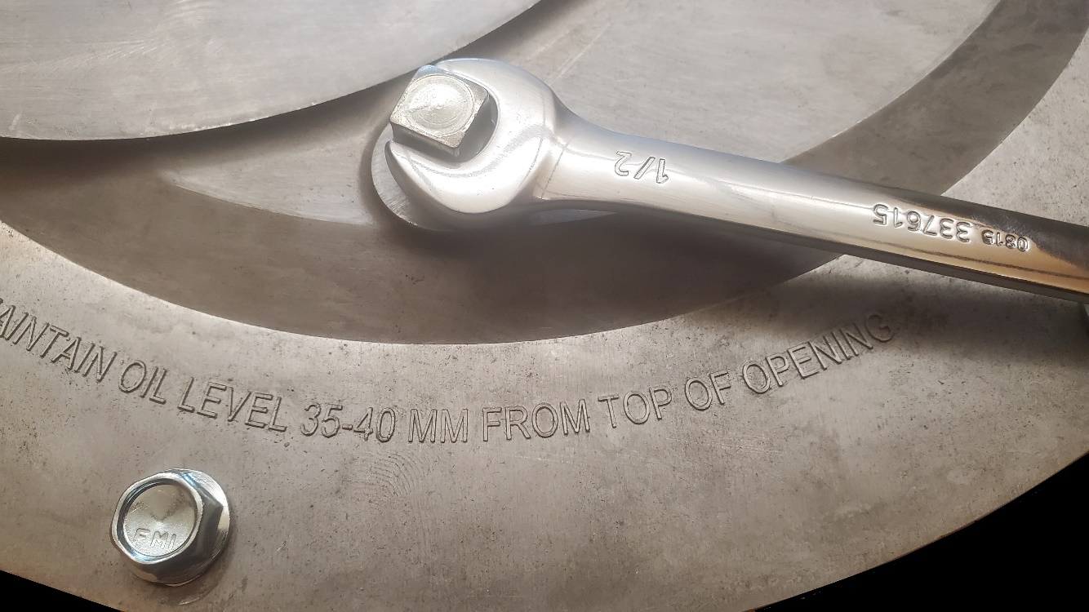

Engine/Pump Start-up Recommendations:
- Prior to pumping, start the engine on dry land and run for two minutes to ensure easier starting once it is placed on the water. Ensure to pull engine start cord just as pump is shutting off when it has run dry.
- Ensure the hose does not have a twist in it before starting the engine to begin pumping.
- Run the pump at full throttle as your WARTHOG PUMP is engineered to run at full throttle.

Fluid Level Checks:
- Check the gear case oil level every 24 hours and/or before every use and add if required.
- Check the engine oil level before every use and add if required.
BREAKING IN YOUR PUMP AND
STARTING YOUR WARTHOG PUMP ON LAND
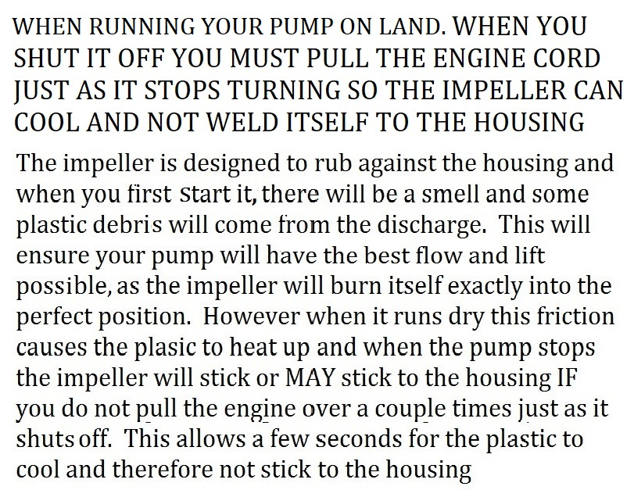

Attaching coupling to hose and pump
- Lay the hose on a flat and even surface with about 5 feet laying flat on the ground.
- Slide the clamps and hose onto the Female Camlock coupling supplied with the pump.
- Ensure that the handles are level and perfectly horizontal and the hose seam is flat on the ground and also perfectly horizontal
- Tighten the 2 hose clamps so the seam of the hose and the handles remain horizontal and both are secured in this position.
- When you attach the hose to the pump ensure the handles are in the horizontal position.

AUXILLARY FUEL TANK
Ensure that you push the female marine fitting all the way into the brass male fitting until it clicks and only then will it be held into place.
The 3-way fuel valve will draw from either the on-board tank or the Auxiliary fuel tank. It can not draw from both tanks at the same time.
Point the handle of the valve so that it points to the fuel hose that you wish to be drawing fuel from.

PUMPING- START UP PROCEDURES

PRIOR TO STARTING THE PUMP Ensure there are no twists or kinks in the hose.

ALSO PLEASE NOTE THAT ONCE THE PUMP IS SHUT OFF THERE IS A CHANCE THAT THE HOSE MAY HAVE TWISTED ONCE THERE WAS NO LONGER WATER MOVING THROUGH IT. IT IS COMMON FOR THE HOSE TO SHIFT AND MOVE UPON START UPS AND SHUT DOWNS SO YOU MUST INSPECT THE ENTIRE HOSE EVERY TIME BEFORE YOU RESTART THE PUMP.
EVERY TIME YOU START THE ENGINE YOU SHOULD WALK ALONG THE HOSE THE ENTIRE LENGHT AS IT FILLS TO ENSURE IT DOES NOT MOVE OR SHIFT AND CAUSE A TWIST IN THE HOSE
IF A TWIST OCCURES THAT YOU CAN NOT GET OUT BEFORE IT FULLY PRESSURIZES, RETURN IMMEDIATELY TO THE PUMP AND SHUT DOWN THE MOTOR TO STOP THE HOSE FROM OVER PRESSURIZING AND BURSTING.

Anchoring and positioning the Hose:
When using the optional Warthog Hose Hold-down Kit.
EVEN A LIGHT BREEZE CAN FLIP OVER AND TWIST THE HOSE
To prevent the empty hose from being twisted and blown on windy days secure the hose by INSETING A PEG ON EACH SIDE OF THE HOSE AND SLIDING THE BUNGEE OVER THE PEGS AND SLIDING IT DOWN TIGHT TO THE GROUND. INSERT PEGS ON AN ANGLE OUTWARDS TO HELP THE CORD STAY CLOSE TO THE GROUND AS SEEN IN THE PICTURE BELOW.
THE BUNGEE WILL STRETCH AND ALLOW THE HOSE TO TAKE ITS SHAPE WITHOUT RESTRICTING THE FLOW. ONCE THE PUMP IS SHUT OFF TO REFUEL OR MOVE IT THE BUNGEE WILL PULL THE HOSE BACK DOWN TO THE GROUND AND SECURE IT THERE.
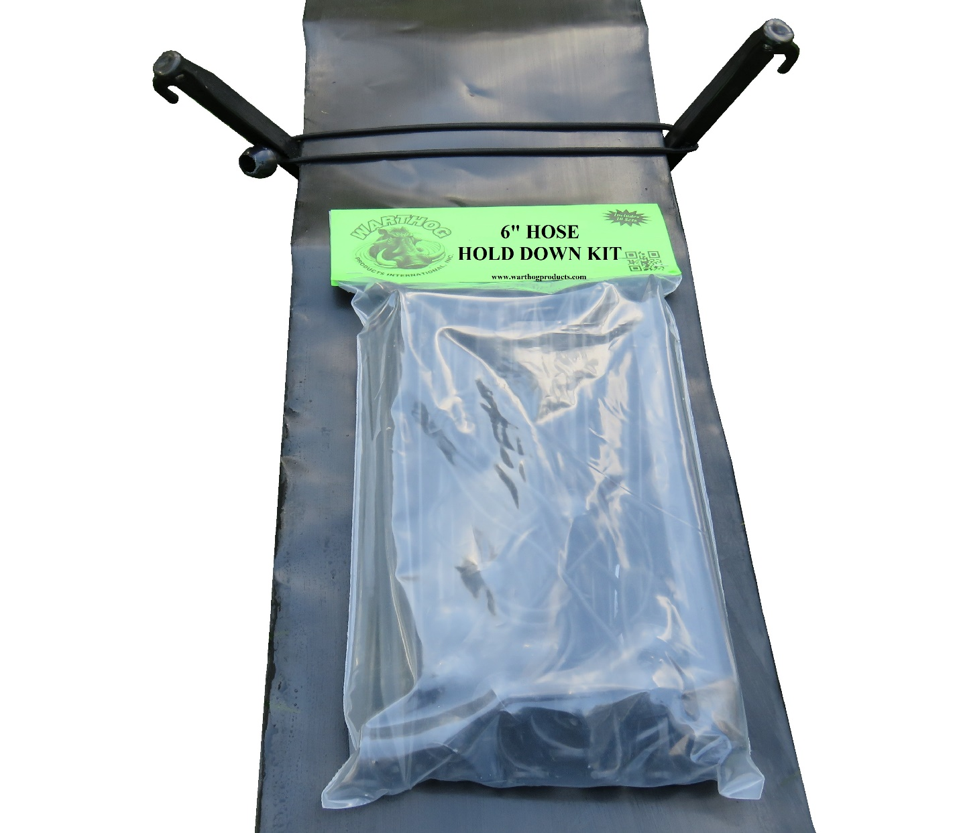
The tie-downs should be used every 10 to 15 feet (3 to 5 meters)

THE HOSE MAY WANT TO ROLL DOWN A SIDE HILL
INSERT PEGS CLOSE TO THE HOSE ON THE LOWER SIDE OF THE SIDE HILL AS CLOSE TOGETHER AS MAY BE REQUIRED BY THE SLOPE AND OR TERRAIN. ONCE THE HOSE FILLS UP IT WILL ROLL TILL IT RESTS AGAINST THE PEGS AND ARE SECURED FROM FURTHER ROLLING. IF AND WHEN THE PUMP IS SHUT OFF CHECK THESE AREAS WELL AND ENSURE THE HOSE HAS NO TWISTS AND IS LAYING FLAT. ENSURE YOU WALK ALONG THE HOSE UPON RESTARTING THE PUMP TO ENSURE HOSE STAYS IN PLACE.

SECURING THE PUMP
IT IS ADVISED TO TETHER THE PUMP AT ALL TIMES by fastening a rope to the handle closest to the hose connection and fasten the other end to a stake or secure object. IN THE EVENT THAT THE HOSE GETS YANKED OFF OR THE COUPLING COMES APART THE PUMP WILL ACT IN THE SAME MANNER AS A JET BOAT AND GET AWAY FROM YOU.
In the event that there is a side wind or waves the WARTHOG PUMP may be secured by fastening a rope to the handle closest to the hose connection and fasten the other end to a stake or secure object at as wide an angle to the hose as possible.

Maintenance:
Engine – Refer to engine operator’s manual for engine maintenance.
Gear Case:
- Check the gear case oil level every 24 hours and/or before every use.
- Change oil in the gear case every 500 hours and also at the end of each season if storing the pump.

Storage of the Warthog Pump:
When storing the Warthog Pump - drain the fuel tank, drain the carburetor fuel bowl, oil the carburetor linkage and lube the cylinder head.

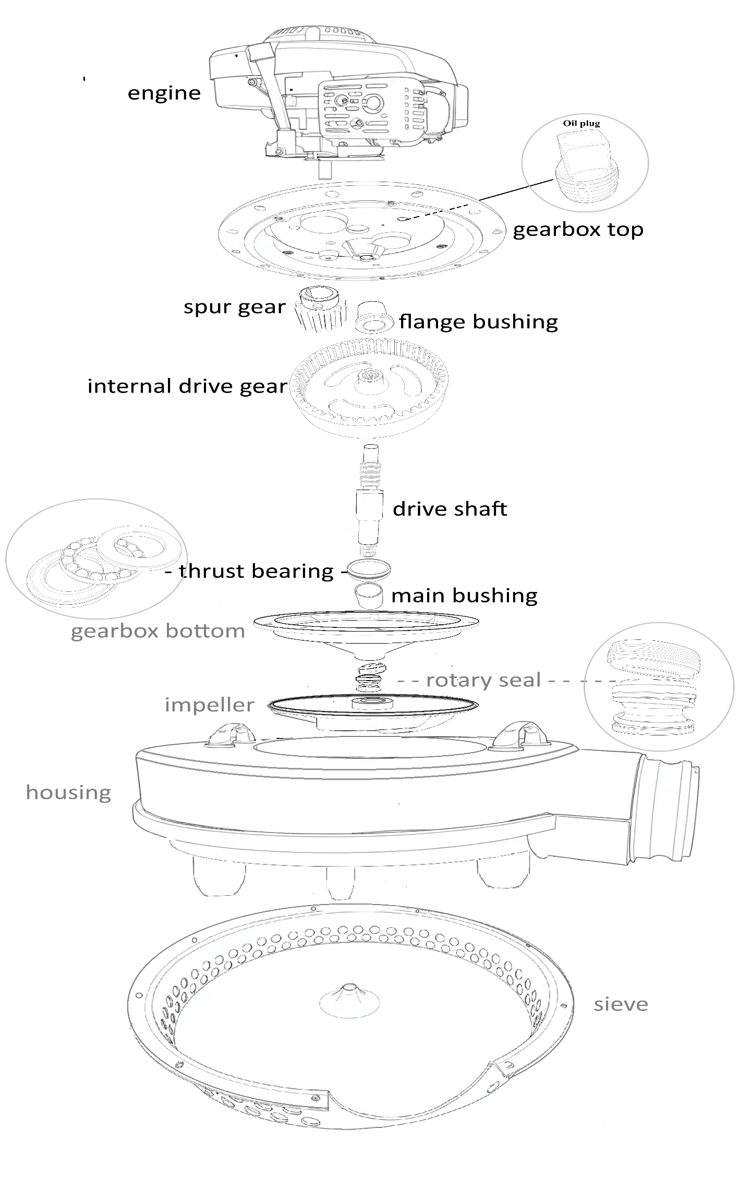
Trouble Shooting:
Problem Cause Solution
Pump not level in water Twisted hose Ensure that the hose is lying flat before . . connecting the camlock coupling
Leaky Hose Holes or tears in hose Repair with patching tape

Hose bursting at pump Too high of lift Use Warthog reinforced commercial hose. hose

Milky colored gear oil Water seeping into gear case replace rotary seal

Engine is difficult to start Fouled spark plug Replace or clean spark plug
Old or poor fuel Supply with new fuel, see engine owner’s manual.

www.warthogproducts.com

